Computer Systems Lecture 8

Pointers

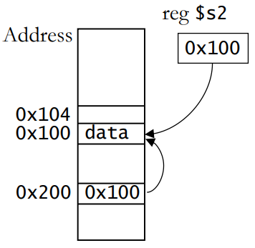We have seen pointers in assembly: **lw $t1, 0($s2**).$s2 points to the location in memory where the actual data is kept. $s2 is a register but there nothing stopping us from having pointers stored in memory like normal variables.

C Pointers

A C pointer is a variable that holds the address of a piece of data.

Pointers are declared using **\***:

**int *p;**  creates a pointer to an integer, the compiler needs to know what data type the pointer points to.

Basic pointer usage:

**p = &I; // p now points to the location of I in memory**

**\*p = 5; // This takes p (now pointing to i) and tells it to access the memory and sets it to 5**

Pointers as Function Arguments

In Java, an argument with primitive type is passed by value and an argument with class type is passed by reference.

In C, all arguments are passed by value, to get the effect of passing by reference we pass a pointer as an argument.

The Swap Function

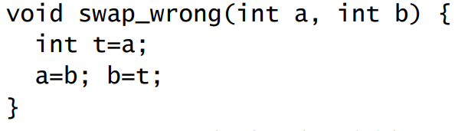

Swap_wrong swaps the local variables a and b which are unknown outside of the function

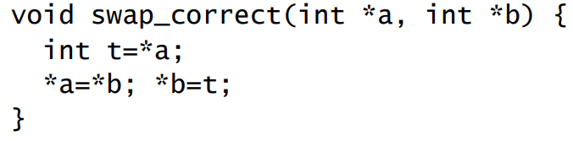

This is the way swap should be implemented, save the value at a in t, set the value of a to the value of b, then set the value of b to the value in t.

Pointer Arithmetic and Arrays

C allows arithmetic on pointers:

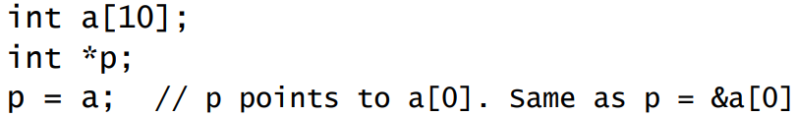

P+1 points to a[1] ( &a[1] = &a[0]+1) ( the compiler multiplies +1 with the data types size needed).

In general p+I points to a[i] and *(p+i) is a[i]

You can also simply use the array (*(a+i) is the same as a[i] as is p[i]) (the difference between a and p is that you can’t change what a points to but you can p).

* 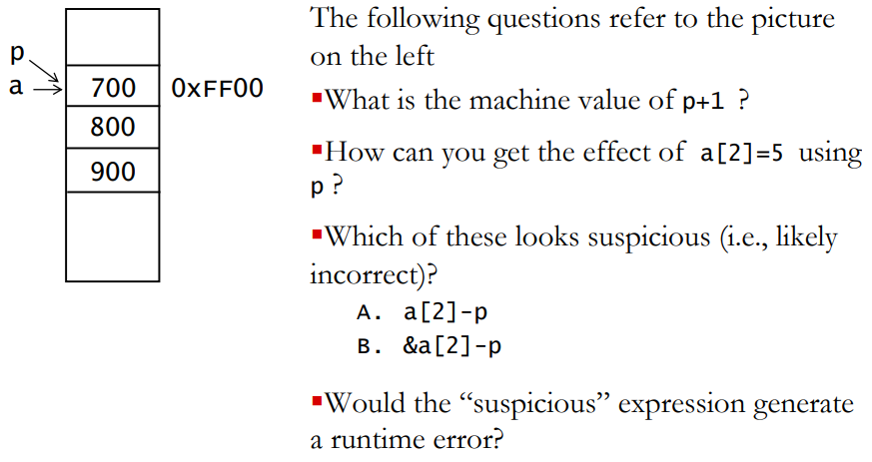p+1 = 0xFF00 + word size
* *(p+2) = 5
* B but A is the one that would break
* no

More Pointer Arithmetic

Common expressions:

* *p++ this retrieves the value pointed to by p and then moves p to point to the next element
* *++p this moves p to point to the next element then retrieves that element.
* (*p)++ increments the value at p
* P=NULL is used to make p point to nothing (!p) will return true if the pointer points to nothing.
* Dereferencing a null pointer will cause a segmentation fault.

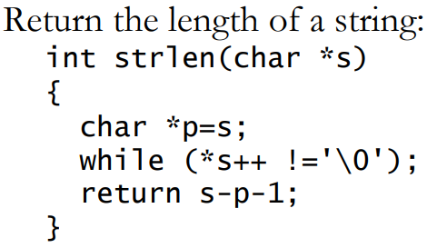

S is local, so we can change it. The pointer is incremented, dereferenced and compared all in one, no body for the loop is needed. At the end of the loop s points to the end of the string, we return s-p (p is the start of the string) -1 to get the number of characters between where we were placed in the array and the null character.

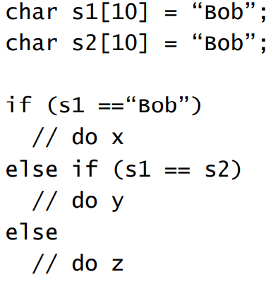

Here z will run as s1 is a pointer which will not point to the literal string “Bob” so the first condition fails, the second condition also fails as the two arrays will be held at different places in memory.

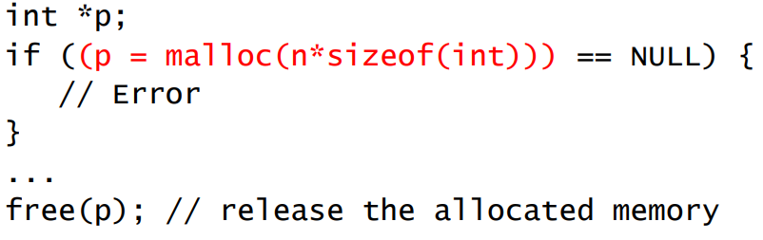Dynamic Memory Allocation  
Pointers aren’t much use with statically allocated data. We can use malloc to allocate a chunk of memory at run time and return the address:

Note the free(p) at the end, mallocs must always have a corresponding free.

Pointers to Pointers

Consider an array of strings char *strTable[10];

The strings are dynamically allocated and so can be any size, but the table size is fixed to 10 strings. If we don’t know the number of strings ahead of time we’ll need to dynamically allocate the storage for the array of strings as well, meaning we should define: char **strTable;